Living as a Consumer Assignment
Student Name
Institutional Affiliation
Due Date

An example of an advertisement
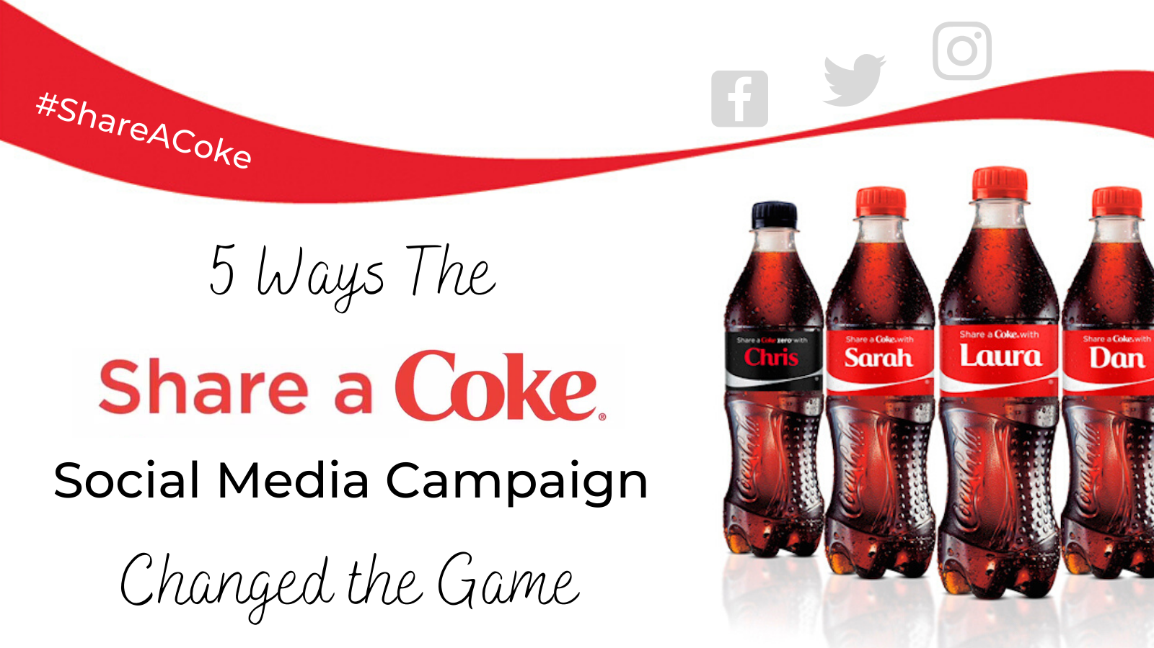
https://medium.com>coca-colas-shareacoke-social-media
The above advertisement is selling the coca-cola brand with personalized bottles containing individual names and whereby people can share a coke with the names of friends or family members. The Coca-Cola Company was behind this advert when it personalized its bottles, a campaign that began in 2011 in Australia by the advertising agency Ogilvy after which the US followed. The campaign has since been adopted by more than 80 countries.
Some of the unique characteristics of this advertisement include promotional, persuasive, part of the company’s marketing strategy, original, creative, personalized, and ethical. A promotional advertisement publicizes its products or services to the consumers. This advertisement is therefore promotional because it has focused on influencing its customers to keep purchasing their brand.
This advertisement is also persuasive because it has tried to convince consumers that coca-cola is a better brand compared to other brands due to its personalized bottles. The advertisement has used numerous resources including appealing to the emotions of consumers, winning the consumers’ trust, and using rational reasons to explain the worth of the brand. This advertisement is also part of the marketing of the Coca-Cola Company. The advertisement has used creative features such as personalized bottles. It has also social media as a marketing strategy for the Coca-Cola brand.
The advertisement is also original because the Company has gone out of the box and created something unique. It has not used the usual formats used by most companies in their advertisements. The advertisement is creative because it has used identifiable images and writings that will remain memorable to the consumers which will ensure that they remain faithful to the brand. The advertisement has used personalized Coca-cola bottles to meet the needs of consumers of sharing love with their friends and family members. The advertising is also ethical because it does not give unethical or misleading information. The company took it upon itself to regulate the ethical features of advertising.
This advertisement aligns with y interests because, firstly, it has used social media marketing which interests me most. I use social media more often so this advertisement has aligned with my interest. I prefer Facebook advertisements since I spend more time on Facebook. The advertisement has also aligned with my interest in sharing with family and friends. I can share a Coca-Cola with the names of my friends or family.
The advertisement might have been targeted at me due to numerous reasons. First, advertising has relied on social media such as Facebook, Twitter, and Instagram. It has targeted me because it is in social media where I spend more time unlike mass media such as television and radio. The advertisement has also been designed attractive and appealing to the needs and feelings of the consumer. Its attractiveness makes me think that it targeted my feelings. The advertisement is also sociodemographic targeting because it has focused on the characteristics of the consumers including age and generation. The current age and generation (18-24 years) like having fun together as friends. This advertisement has therefore catered for our needs by offering personalized coca-cola bottles which we can share happiness. I feel targeted because I belong to this age and generation. The advertisement has also targeted the behavior of this young generation who like taking fast foods including drinks.
Some of my previous consumptive habits which have impacted the likelihood of seeing this advertisement include impulse buying habits and programmed behavior. Impulse buying involves purchasing unplanned products. When I go to a supermarket, I find myself buying more items that I never intended to buy. This habit led to me seeing the advertisement because I can buy the Coca-Cola brand even if I had not planned. Programmed habit includes buying frequent buying of low-cost products including drinks. This influenced me to see the advertisement because drinks can be automatically purchased at cheap prices. The fact that I can frequently buy low price products made me attracted to the advertisement. Another habit that impacted my seeing of the advertisement is limited decision making. I occasionally buy products after somebody recommends them. Some of my friends who have already used this Coca-Cola brand recommended that I should try it. This impacted my seeing of the advertisement to confirm the brand.
This advertisement appeals to me because I feel that it was accurately targeted. The advertisement was targeted because of how it communicated: it communicated its purpose of sharing a coke with friends or family members; it met the targeted audience by using social media channels and clearly defined the product being advertised. The words and images used in the advertisement are appealing for example the names in the bottles are convincing consumers that they can have the names they like written in the bottles.
The advertiser could improve their advertising strategy by being emotional whereby the advertisement should not only be rational by focusing on the benefits of the product but should also include emotional aspects to create stronger campaigns (Lu & Navas, 2021). The advertiser can also try to be humorous to make people like the product more. The advertisement can also be improved by including promotions, for example, offering prizes to consumers. Another way of improving the advertisement is by regularly updating the content instead of creating new ones. The advertiser may also include more video advertisements such as explainer videos because it is a popular marketing strategy. Finally, the advertiser may also try using email marketing by setting up automatic email marketing campaigns.

References
Lu, L., & Navas, J. (2021). Advertising and quality improving strategies in a supply chain when facing potential crises. European Journal of Operational Research, 288(3), 839-851.
https://medium.com>coca-colas-shareacoke-social-media

